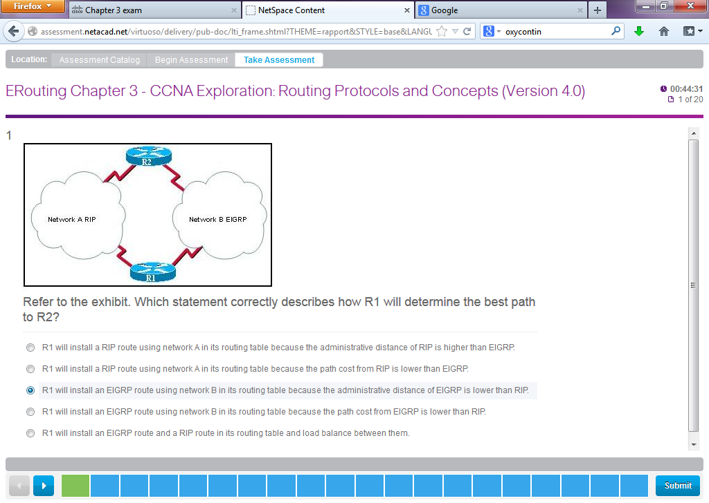

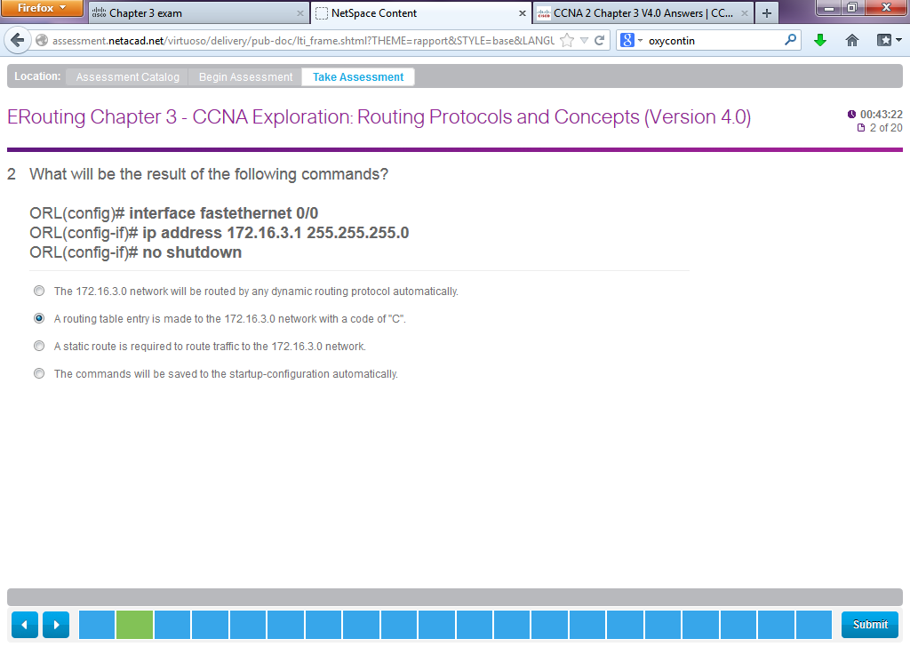

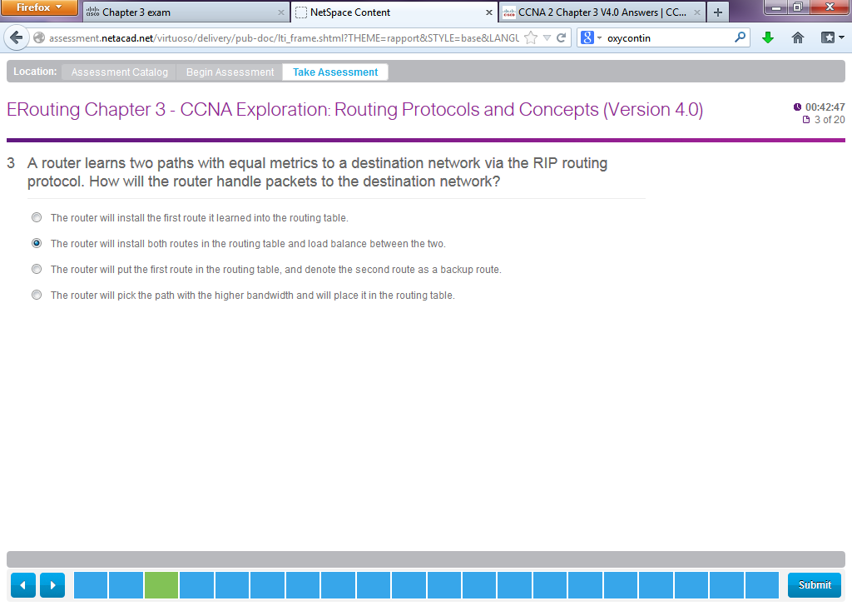

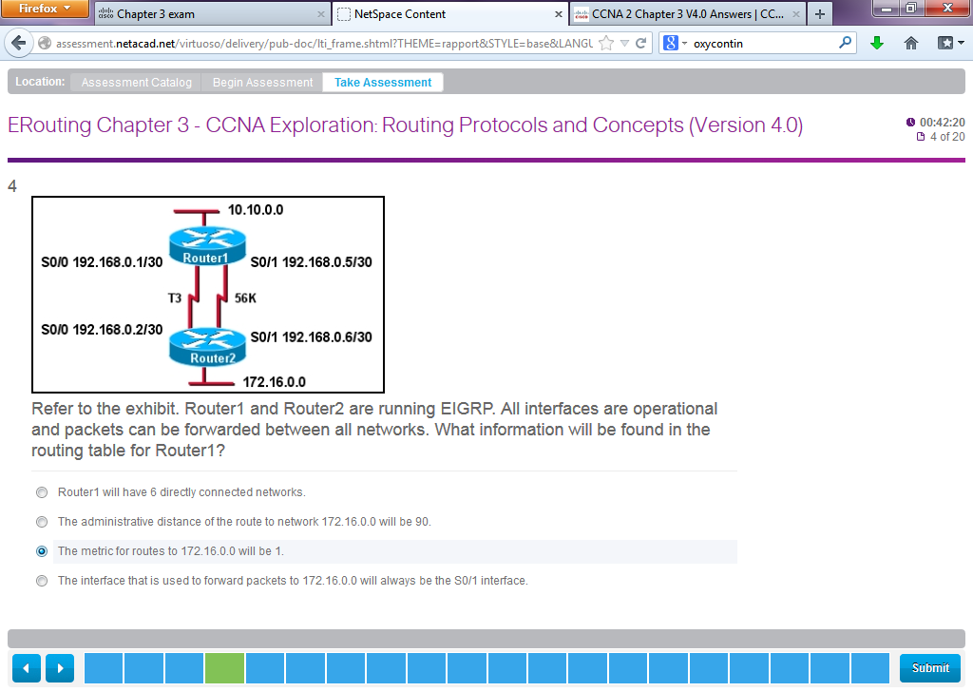

Wrong – correct Answer:

**Refer to the exhibit. Router1 and Router2 are running EIGRP. All interfaces are operational and packets can be forwarded between all networks. What information will be found in the routing table for Router1?**  
Router1 will have 6 directly connected networks.  
The administrative distance of the route to network 172.16.0.0 will be 90.  
The metric for routes to 172.16.0.0 will be 1.  
The interface that is used to forward packets to 172.16.0.0 will always be the S0/1 interface.

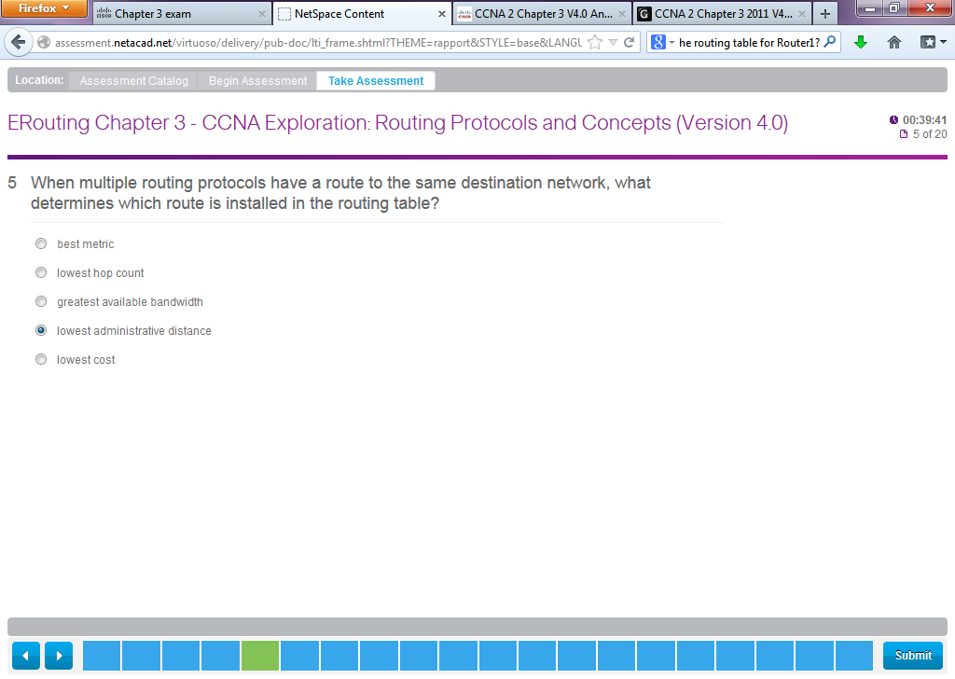

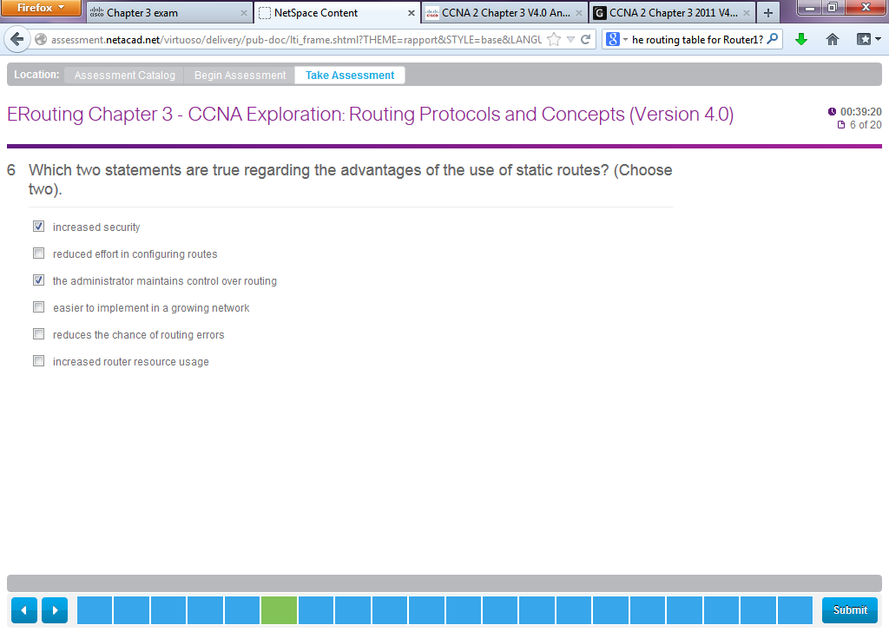

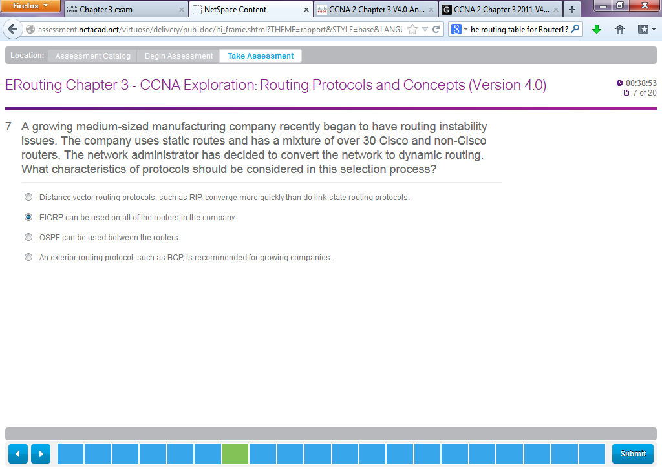

**19**. **A growing medium-sized manufacturing company recently began to have routing instability issues. The company uses static routes and has a mixture of over 30 Cisco and non-Cisco routers. The network administrator has decided to convert the network to dynamic routing. What characteristics of protocols should be considered in this selection process?**  
Distance vector routing protocols, such as RIP, converge more quickly than do link-state routing protocols.  
EIGRP can be used on all of the routers in the company.  
OSPF can be used between the routers.  
An exterior routing protocol, such as BGP, is recommended for growing companies.

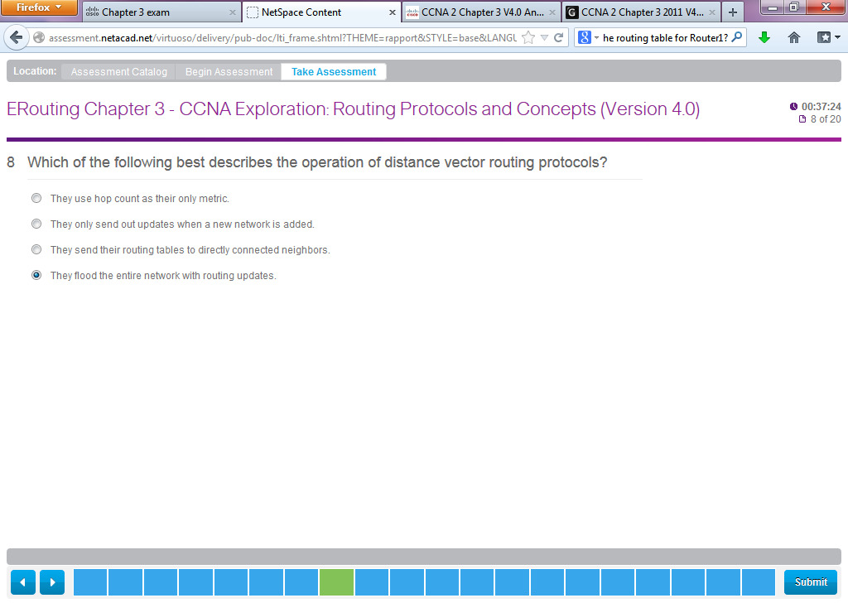

Wrong – Correct Anser:

**8**. **Which of the following best describes the operation of distance vector routing protocols?**  
They use hop count as their only metric.  
They only send out updates when a new network is added.  
They send their routing tables to directly connected neighbors.  
They flood the entire network with routing updates.

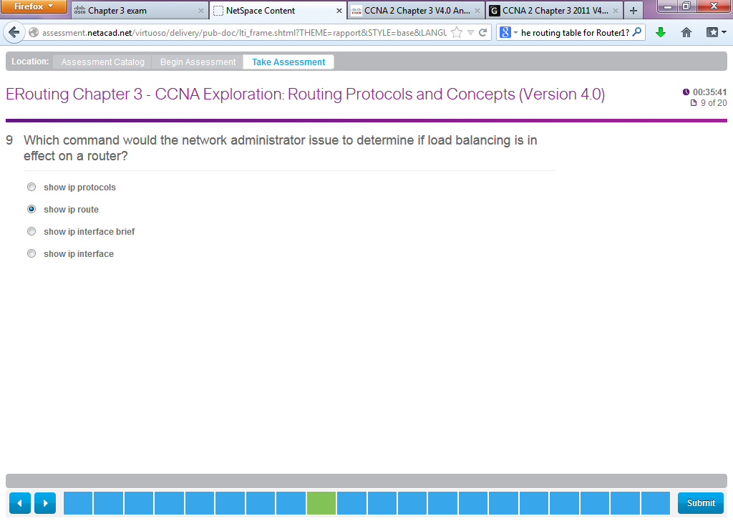

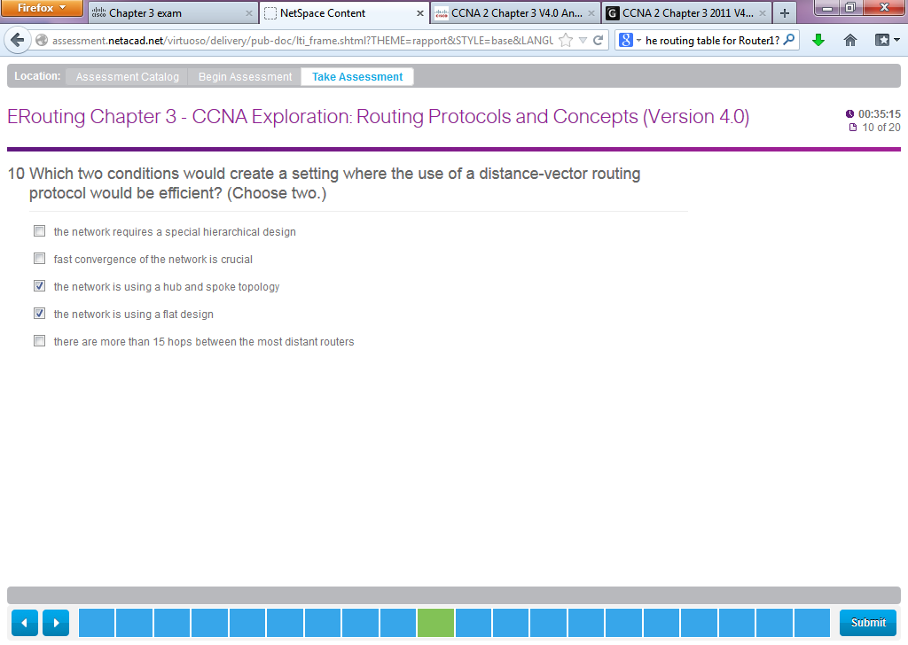

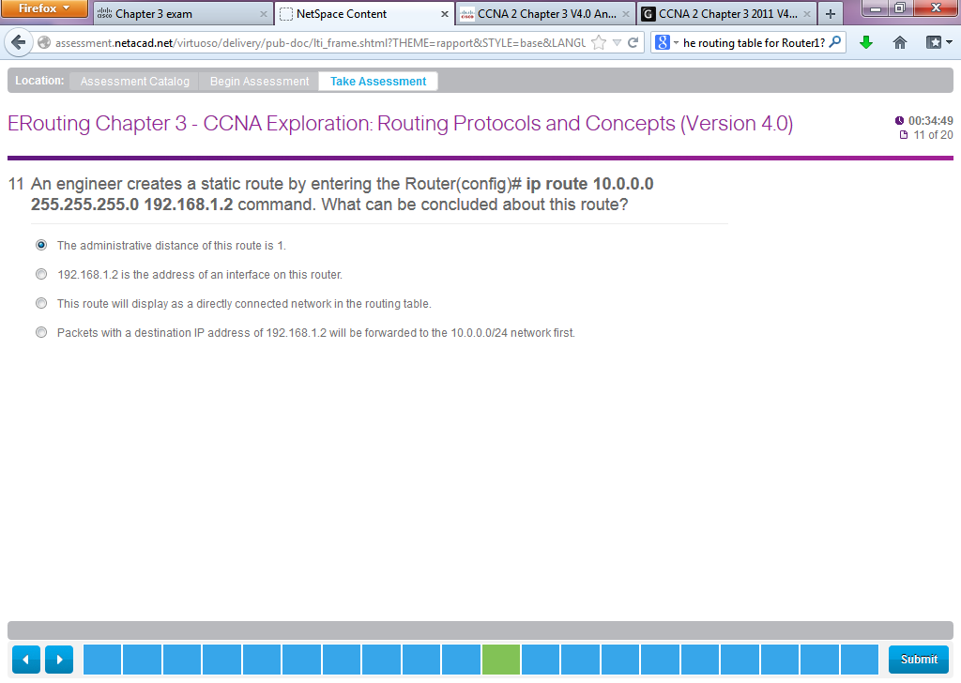

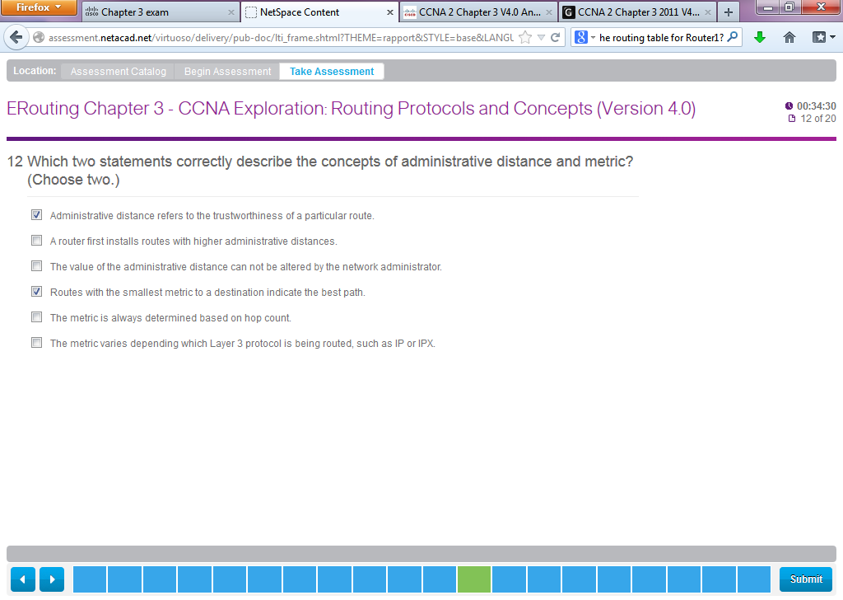

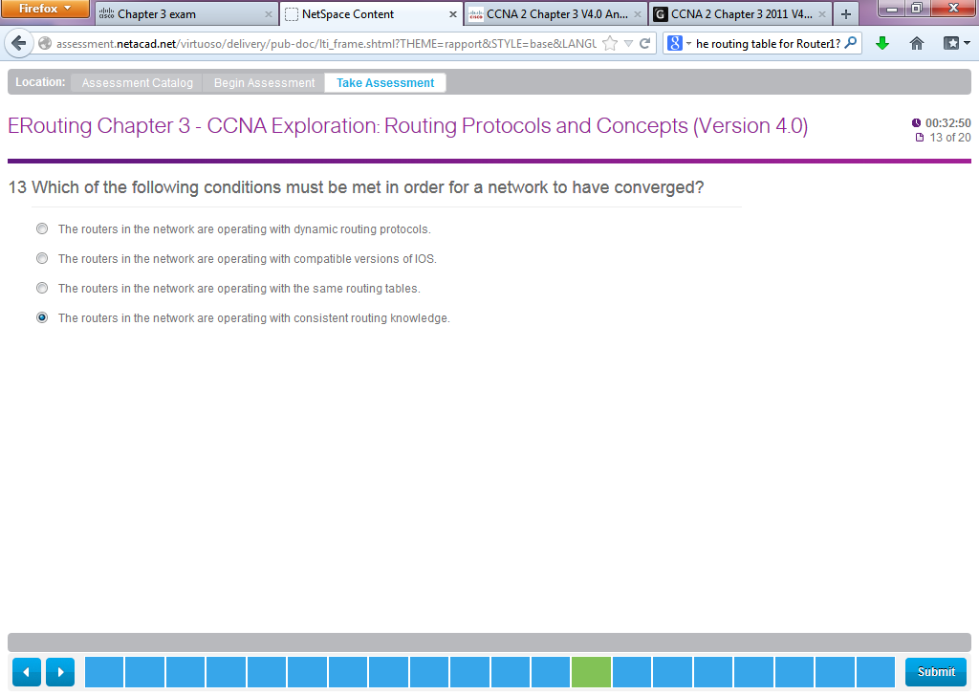

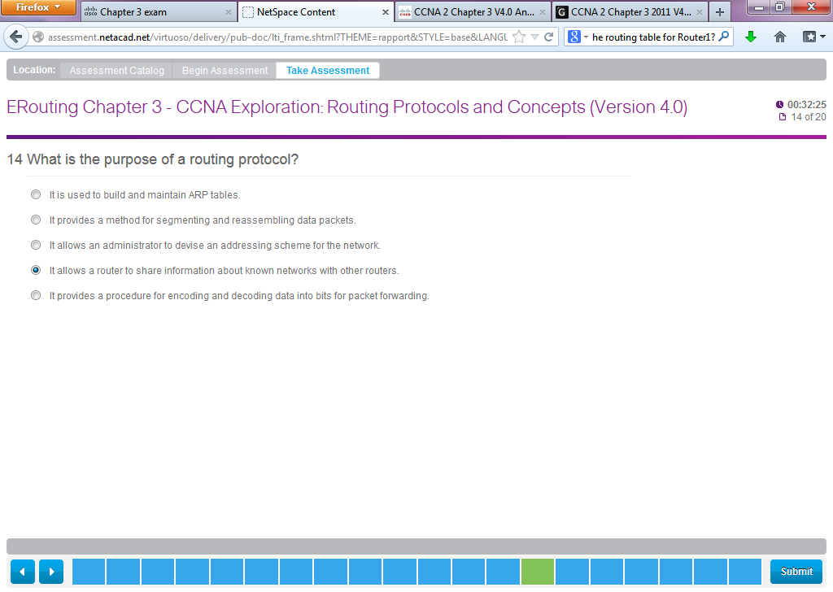

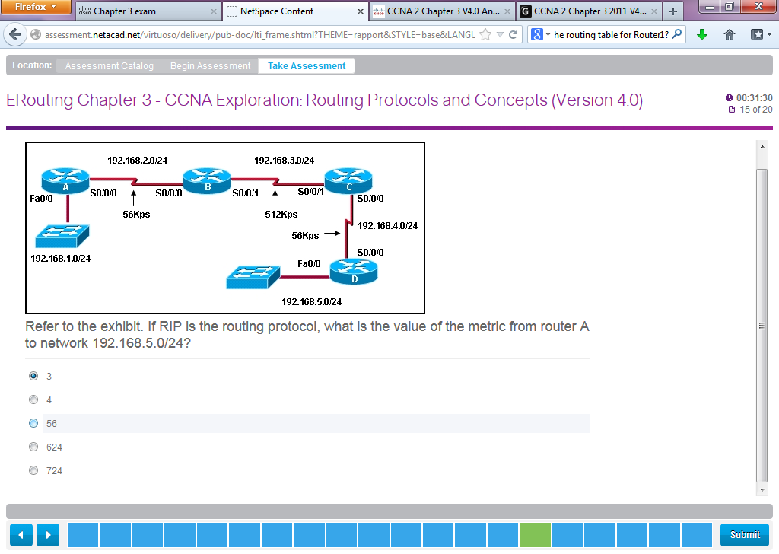

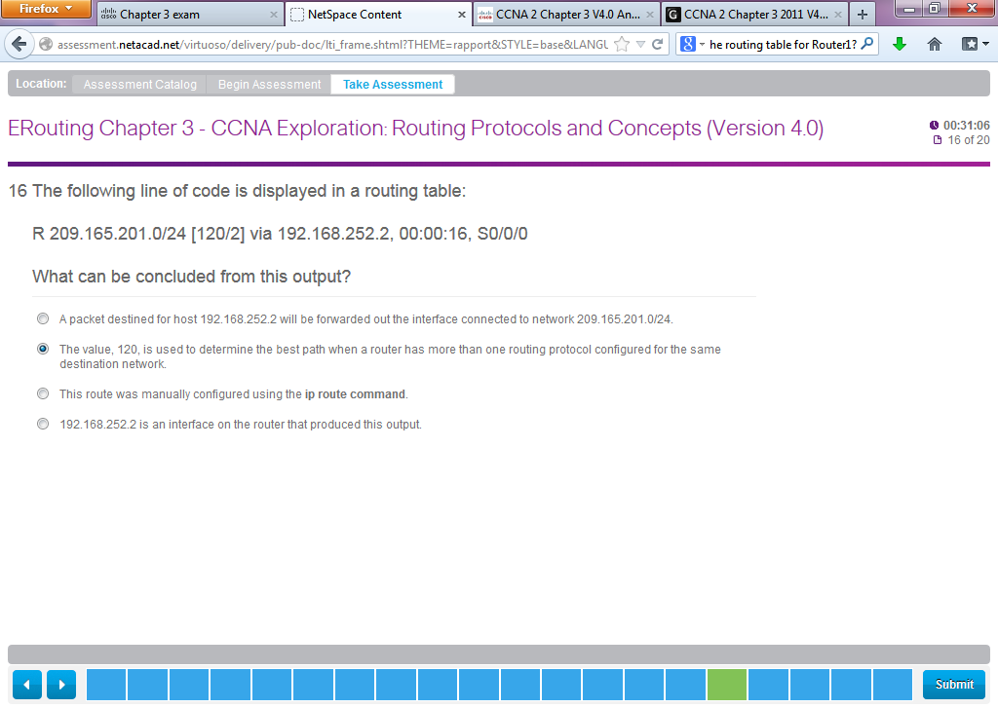

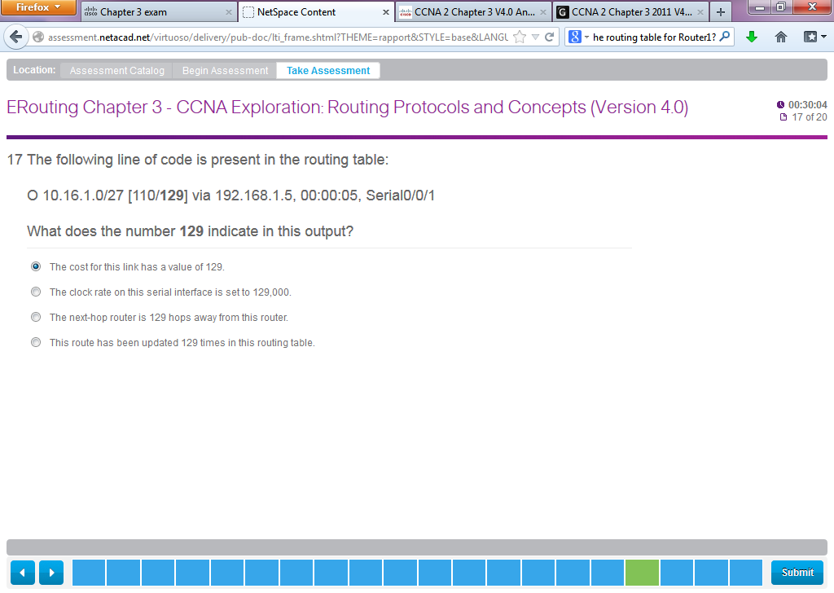

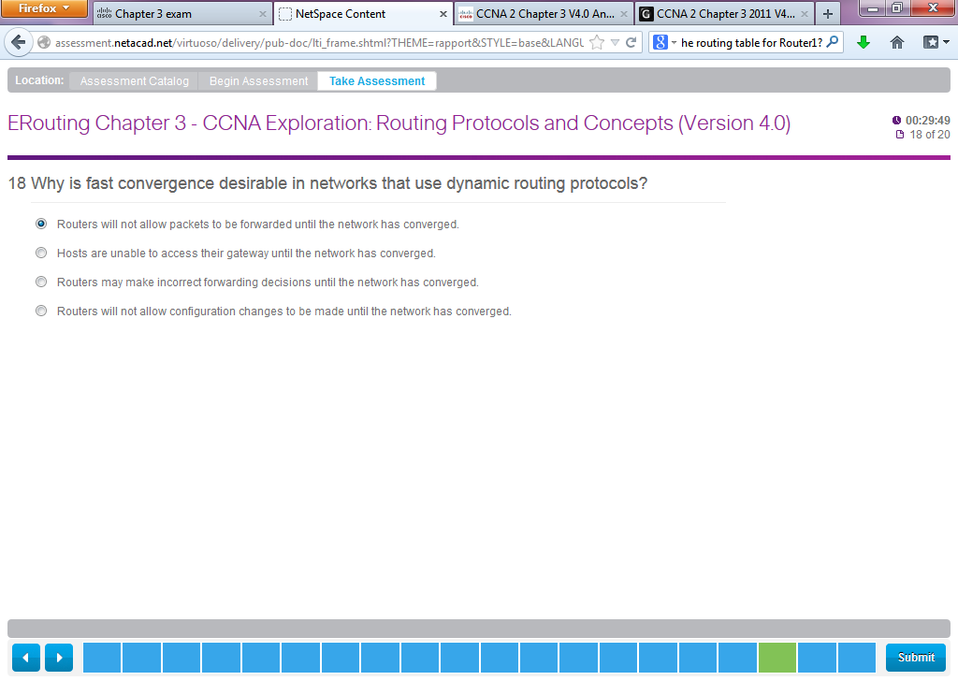

**10**. **Why is fast convergence desirable in networks that use dynamic routing protocols?**  
Routers will not allow packets to be forwarded until the network has converged.  
Hosts are unable to access their gateway until the network has converged.  
Routers may make incorrect forwarding decisions until the network has converged.  
Routers will not allow configuration changes to be made until the network has converged.

